Digital Forensic Investigation Report
Investigator: Alish Mahat (23000965)
Date/Time of investigation: 01 January 2026
Place: Kathmandu, Nepal
Case: Workplace Data Theft and Blackmail – Case 2

Contents
Contents 2
Investigator Details 3
Summary 3
Evidence Investigated 3
Software Utilised 4
Forensic Analysis 4
Relevant Findings 5
Forensic Examiner’s Conclusion 9
Appendices 9

Investigator Details
- Investigator: Alish Mahat
- Qualifications: Currently studying BSc (Hons) Cybersecurity and Digital Forensics
- Experience: Skilled in using forensic tools such as Autopsy, FTK Imager, and Regripper to conduct digital forensic investigations.

Summary
This report provides the results of a digital forensic examination performed on a Windows XP forensic image (E01 format) associated to the suspect, Sam. The investigation was triggered after there were allegations of theft and misuse of confidential data of the company's customers, followed by blackmail of a colleague, Bahadur.
The scope of examination was aimed at identifying digital artefacts that demonstrate theft of data, storage of data, concealment of data, encryption of data, deletion of data, and use of the data for coercive purposes. The analysis uncovered several artefacts such as customer credential files, chat records, payment-related documents, compressed and encrypted containers, steganographic images and supporting system artefacts. Collectively, these finds point to deliberate and methodical behaviour that is consistent with data theft and blackmail.

Evidence Investigated
The following types of evidence were reviewed in the investigation:
- Customer credentials, payment demands and communications in text documents
- Image files that are related to meetings, data transfer and concealed information
- Browser history artefacts related to research and communication activity
- Recycle bin deleted and recoverable files and unallocated space
- Compressed archives and password protected containers
Encrypted VeraCrypt container files
- Steganographic image files
- USB connectivity system artefacts
All evidence was reviewed from a verified forensic image and data integrity was preserved throughout the investigation.

Software Utilised
- Autopsy (v4.21.0): Primary forensic analysis tool for file system analysis, timeline analysis, deleted file recovery, keyword searches, encryption detection and data carving.
- AccessData FTK Imager (v3.1.2.0): For verification of the integrity of the image, registry analysis and secondary verification of key artefacts.
- RegRipper (v4.0): Used to analyse extracted Windows registry hives to analyse user and system activity
- VeraCrypt(v1.25.9): Used for identifying and mounting encrypted container files.
- 7zip(v25.01): used to extract zip files.
- Windows PowerShell (strings utility): Used to extract hidden information in a suspected steganographic image.

Forensic Analysis
The forensic image was loaded into Autopsy and verified with cryptographic hash values to ensure that the integrity of the image was not compromised. The system time zone was verified before analysis so that the timestamps can be interpreted correctly.
A structured examination was performed starting with user directories and moving through system folders, registry artefacts, internet history, deleted files and external device artefacts. File signature analysis was carried on in order to identify disguised files and compressed archives were examined where applicable.
Files identified as having high entropy were analysed for encryption. Encrypted containers were mounted using VeraCrypt where passwords could be deterministically derived from associated artefacts. Data carving techniques were used to recover deleted images and steganographic analysis was performed on images that were suspected of hiding text.

Relevant Findings

Theme1: Theft of Customer Confidential Data
Text documents that contained confidential customer credentials were discovered in the suspect's documents directory. Files such as Customer Cred.txt contained sensitive information about customers that would not normally be required by the suspect's job. The presence of these files implies the unauthorised acquisition and storage of confidential data.
Supporting artefact included browser history entries and images related to the meeting, suggesting coordination and intent around the handling of the stolen data.
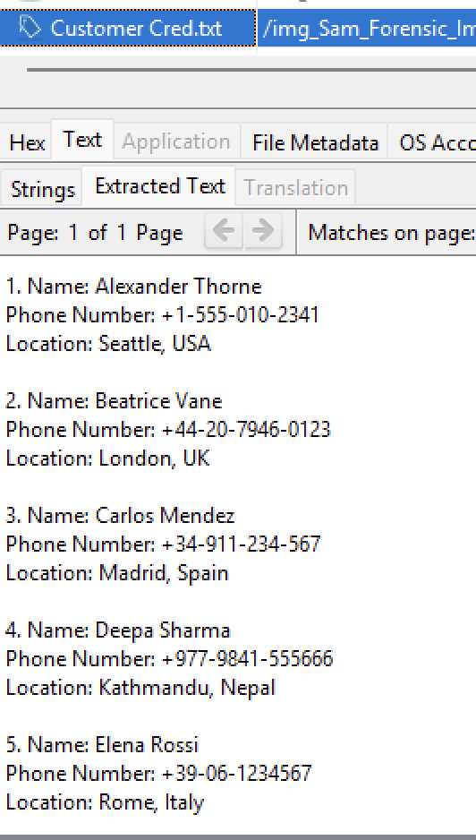
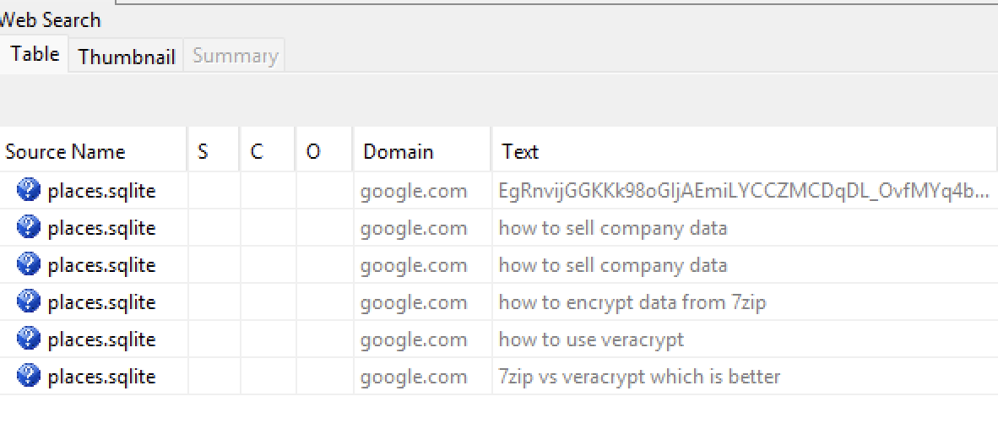

Figure 1:Browser history artefacts

Figure 2:Customer Cred.txt contents
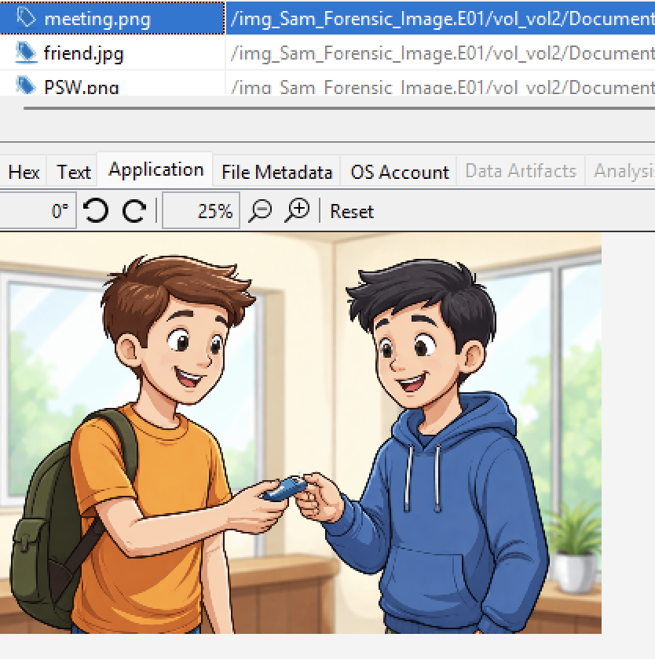

Figure 3:meeting.png

Theme 2: Money Demands and blackmail activity
Files related to financial demands were recovered, including payment.txt and related chat artefacts. These documents show explicit demands for money made by the suspect in return for not disclosing the data stolen. The amounts asked for correspond with the story of blackmail, as described in the case overview.
Recovered communication artefacts support the conclusion that the data was actively used as leverage rather than it being passively stored.

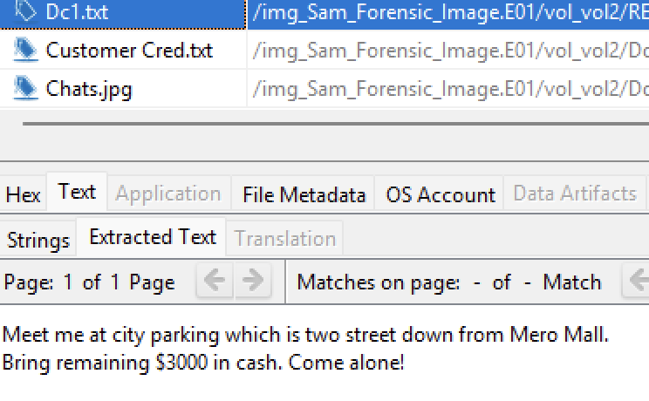
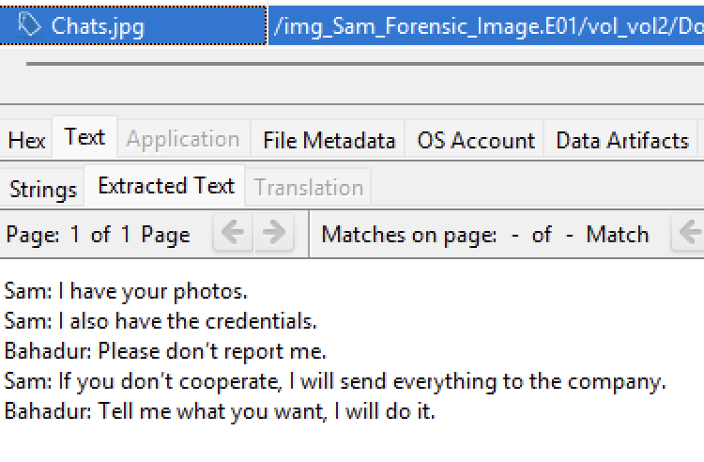
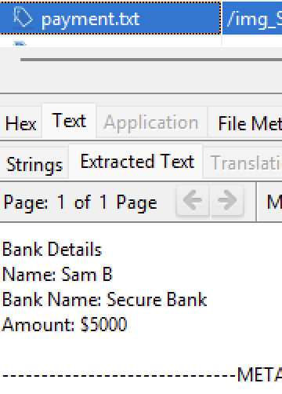

Figure 5:chat artefacts
Figure 4:payment.txt contents

Theme 3: Hiding and Coding of Evidence
The investigation revealed techniques of deliberate concealment that the suspect was using. Multiple files have been compressed and disguised by changes in file extensions, including archives in the form of image files. A password-protected archive (Hand-Over.zip) was found, whose password could be found by artefacts accompanying it which had been deleted from the recycle bin.
A VeraCrypt encrypted container placed inside an 'Important' directory was discovered and successfully mounted. This container contained sensitive files related to the blackmail-related activity, indicating that sensitive incriminating material was intentionally protected.
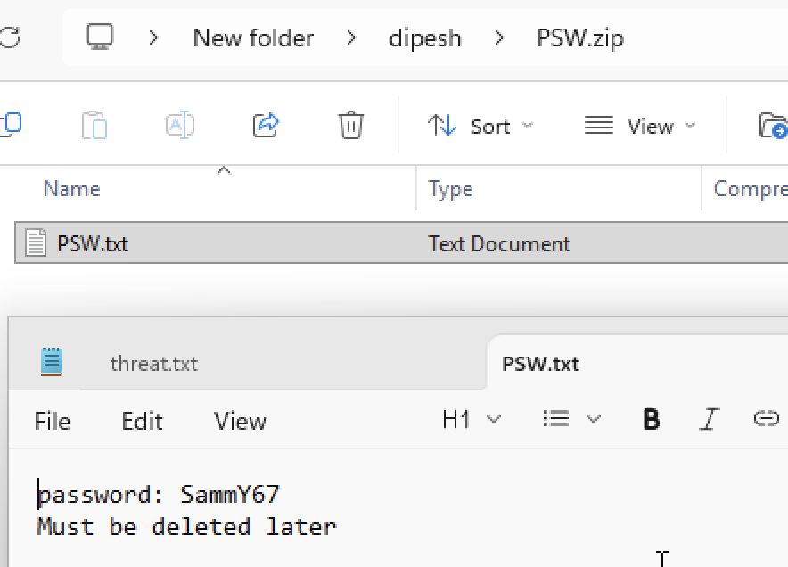
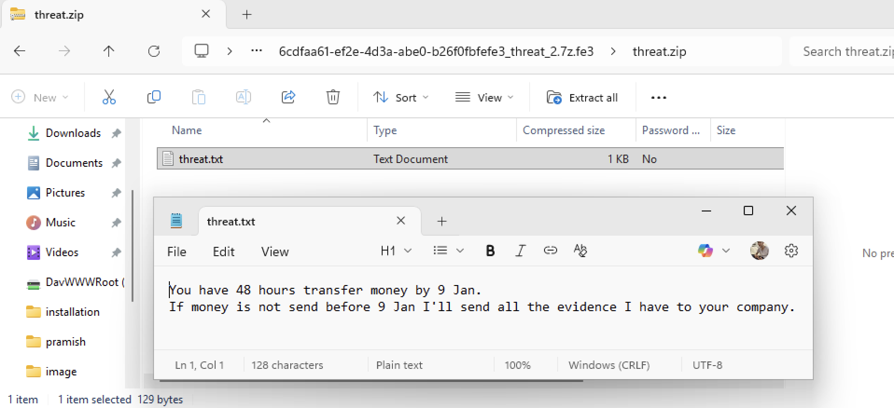
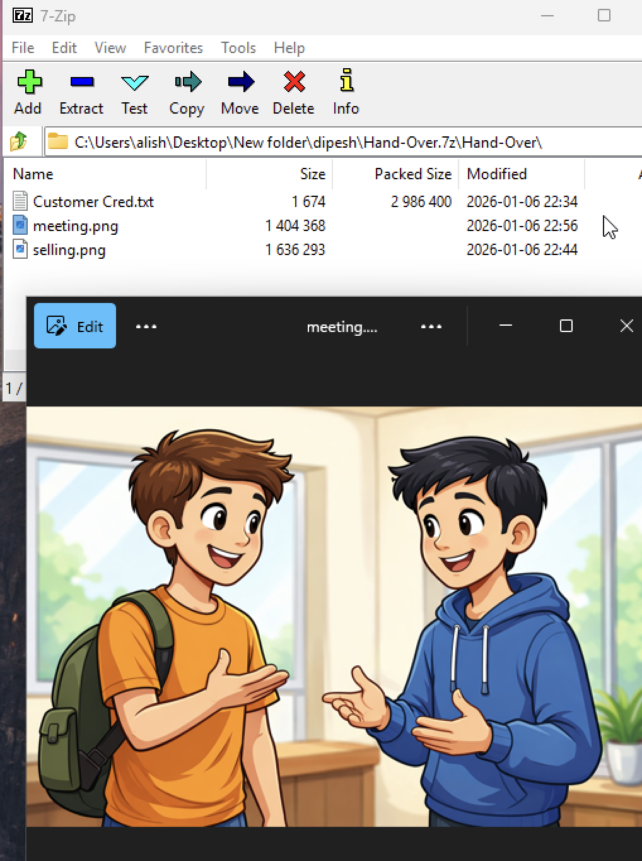
Figure 6: zip inside zip

Figure 7: zip but kept as jpg
Figure 8 password protected zip

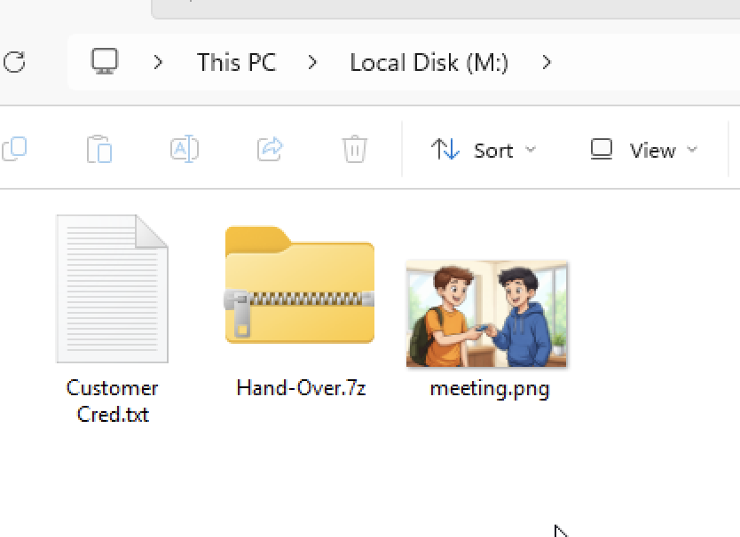
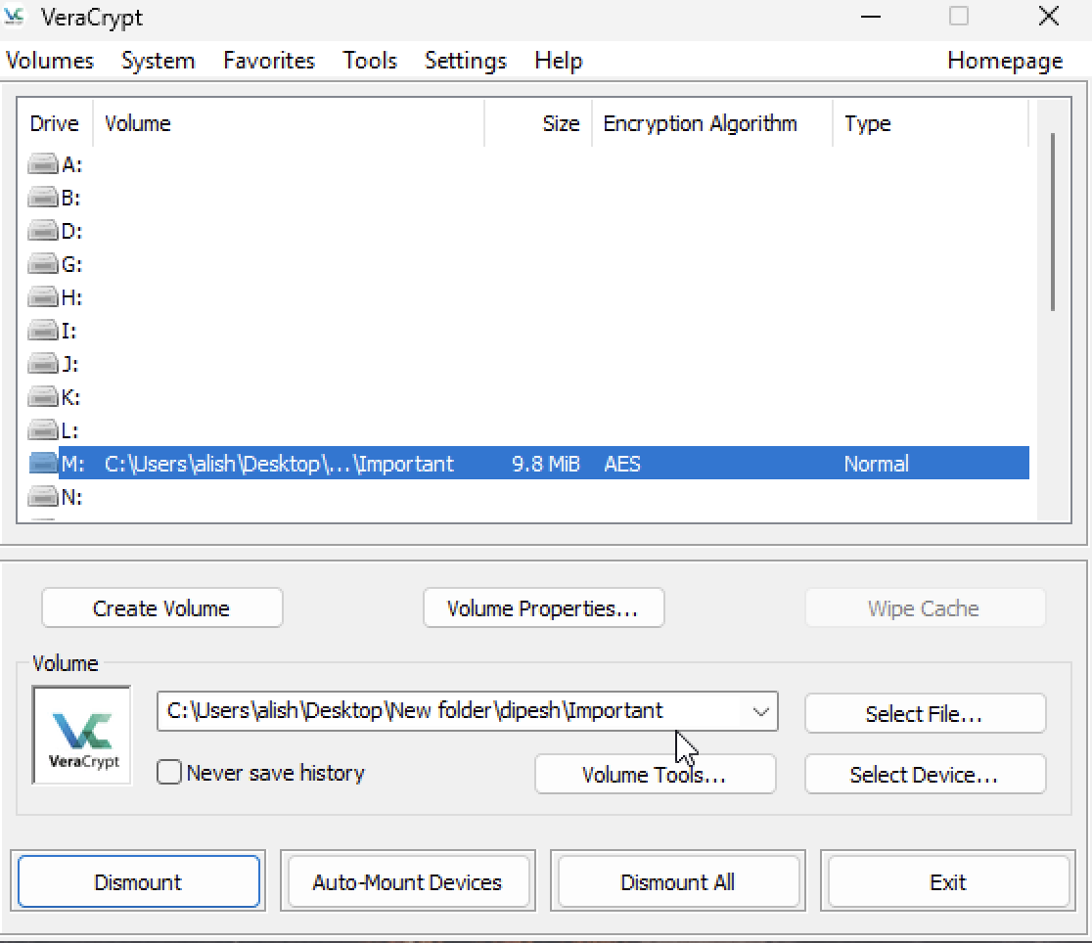

Figure 9 VeraCrypt container detected

Theme 4: Steganography and Erase Evidence
An image file (friend.jpg) was detected as suspicious in entropy analysis. The image was extracted and analyzed in a strings utility accessing Windows PowerShell and the embedded text data was revealed. This proves the application of steganography to hide information in an apparently benign image file.
Additional artefacts were recovered from deleted locations and unallocated space further supporting attempts to remove or hide evidence following the blackmail activity.

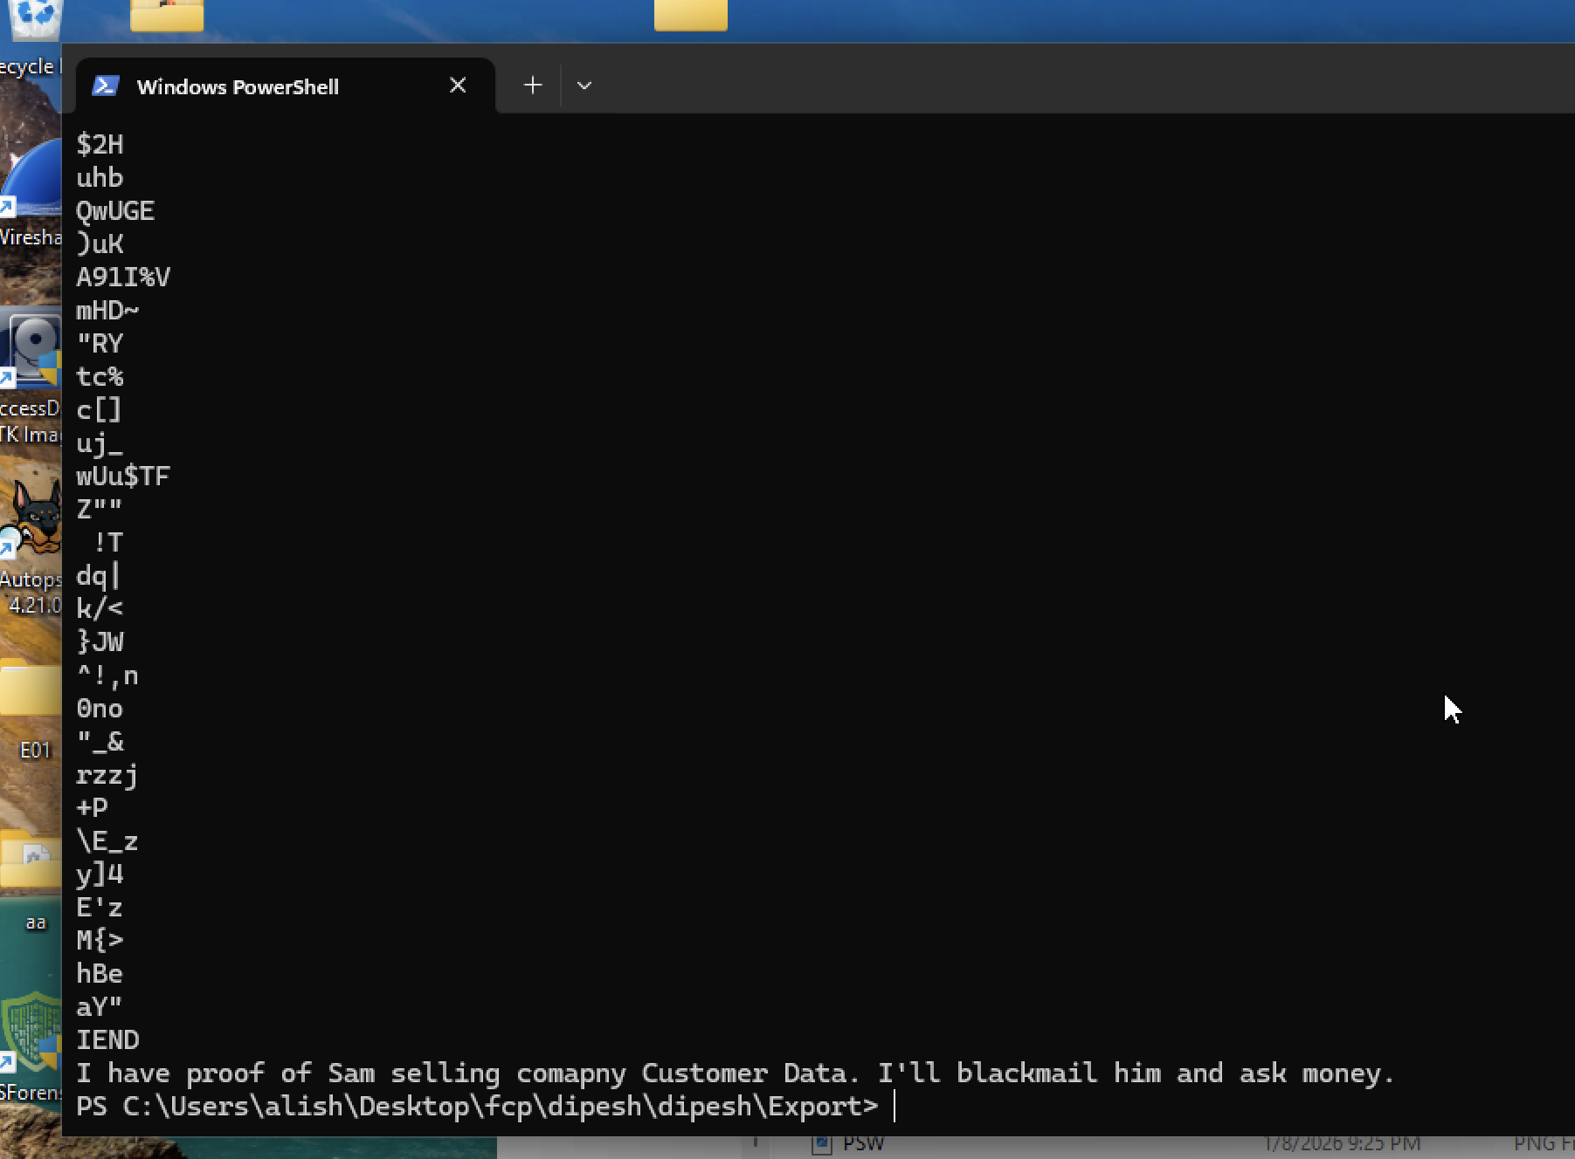
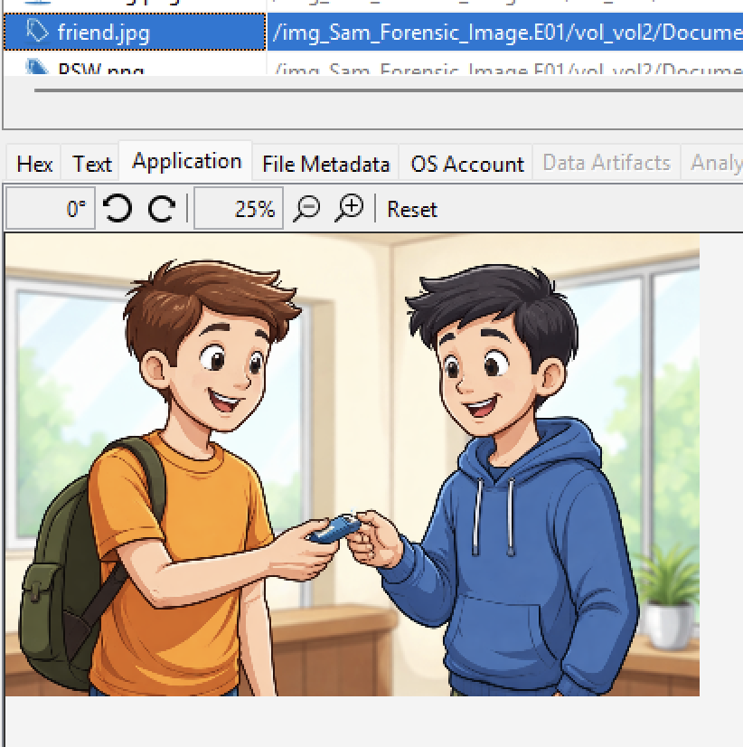
Figure 10: extracted content
Figure 11: stenographic image

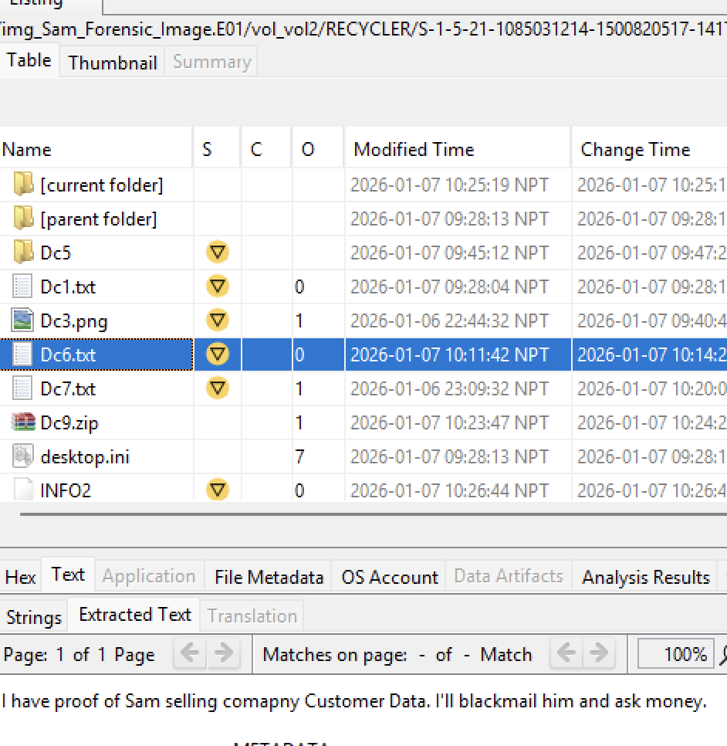
Figure 12: recovered deleted files

Forensic Examiner’s Conclusion
Based on the totality of the digital evidence analysed, it is my professional opinion that the artefacts identified within the forensic image prove unauthorised acquisition of the confidential company data and its subsequent use for blackmail. The presence of customer credential files, financial demand documents, encrypted storage, steganographic concealment and deleted artefacts in combination portray deliberate and calculated behaviour.
This conclusion is based on the digital evidence analyzed only, and is provided to aid investigators and legal authorities. It is not a finding of legal guilt.

Appendices
(Submitted in zip file)
- Html report
- Contemporaneous Notes

